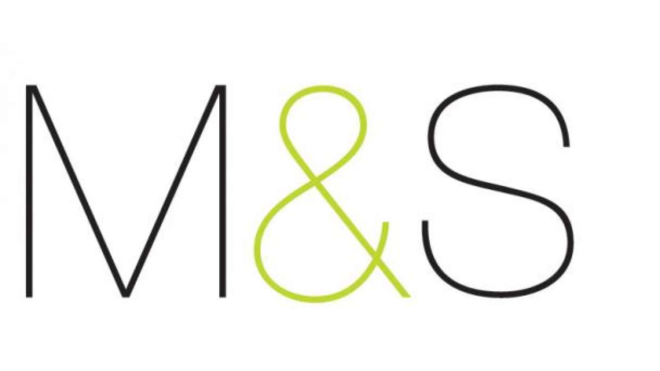

Marks & Spencer

New Relic Synthetics – Site Monitoring

Service Desk - User Manual

Version 1.0

Document Release Notice

Document/Revision details

|  |  |  |  |
| --- | --- | --- | --- |
| Date | Version | Name | Revision description |
| 9-Mar-18 | 1.0 | Subrahmanyam SVS | Initial Version |
|  |  |  |  |
|  |  |  |  |

Contents

1.1 User Roles and Access Rights 2

2 Investigating Monitor Failures 3

2.1 Logging In 3

2.2 Using the Interface for Debugging an issue 4

Appendix: 7

Total number of pages in the manual, including the cover page: **3**

Introduction

New Relic is an Application Monitoring cloud-based product which can be used to monitor in-house applications, intrastructure & websites.

This document talks about ‘New Relic Syntetics’ which monitors M&S websites. This new product is chosen to replace the existing site monitoring tool ‘Site Confidence’.

* 1. User Roles and Access Rights

This section describes the user roles and access rights of various users.

Table 1: User Roes and Access Rights

| Access Rights | Roles | |
| --- | --- | --- |
| Synthetics Admin | Synthetics User |
| Read | Y | Y |
| Edit | Y | N |

Service Desk, Command Centre and IT Ops are given ‘Synthetics User’ access.

Platform Support and few developers are given ‘Synthetics Admin’ access.

1. Investigating Monitor Failures

The below detail explains basic navigation on the New Relic product.

* 1. Logging In

Login to New Relic application

1. Open URL: <https://www.newrelic.com/> and click ‘Log in’ button.
2. Enter your username and password, and click **Login**.

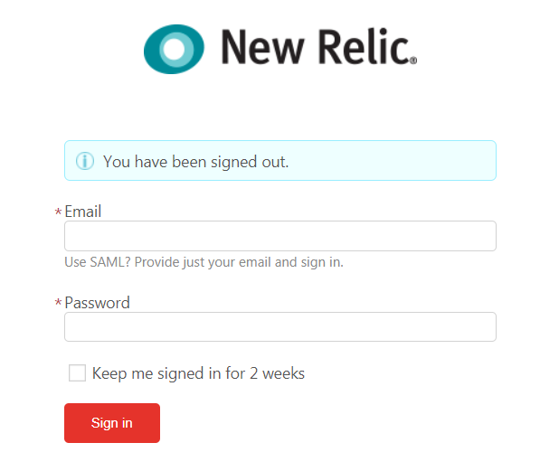

Figure 1: Login Dialog Box

1. Below generic logins have been created for below groups
   1. Service Desk: [ITOpsMultiChannelSupportServiceDesk@marks-and-spencer.com](mailto:ITOpsMultiChannelSupportServiceDesk@marks-and-spencer.com)
   2. Command Centre: [Mands.com-commandcentre@marks-and-spencer.com](mailto:Mands.com-commandcentre@marks-and-spencer.com)
   3. Platform Support: [DL-TCS-MnS.comOperations@mnscorp.onmicrosoft.com](mailto:DL-TCS-MnS.comOperations@mnscorp.onmicrosoft.com)
2. The password can be set using the invite email sent to these email ids.
3. Navigate to Synthetics for details of site monitors.

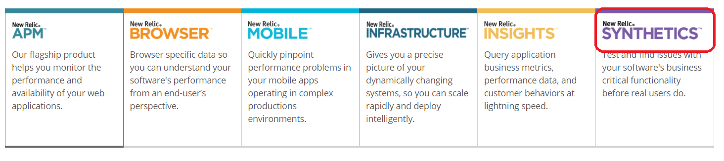

* 1. Using the Interface for Debugging an issue

This section introduces you to the window, navigation and tasks

* + 1. Monitor Investigation

1. Click the menu option ‘Alerts’.



1. Check the ‘Open Incidents’ tab to check for any open incidents. Check for the incident number of Netcool alert in the New Relic page and click on it for details. Jump to Step 4.

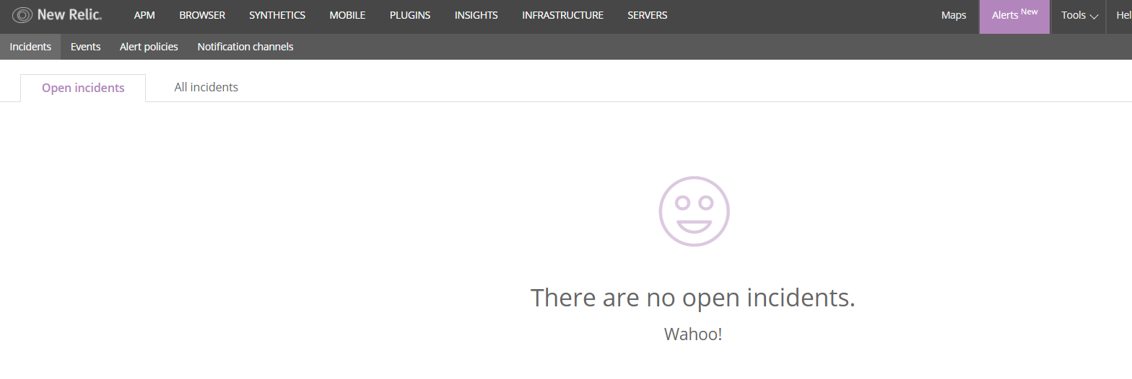

1. If no open incident is found, please check ‘All Incidents’ tab and check if incident number of netcool alert matches the incident number in New Relic. If match, please resolve the incident.

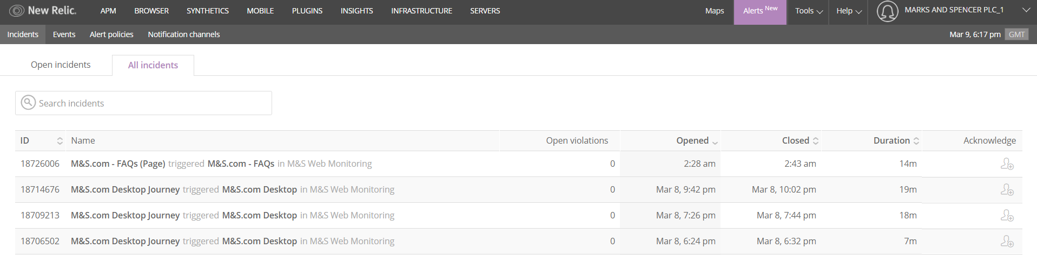

1. New Relic Open incident details would look like below.
   1. Acknowledge the incident.
   2. Click on ‘View Result’ link for a Failed occurrence.

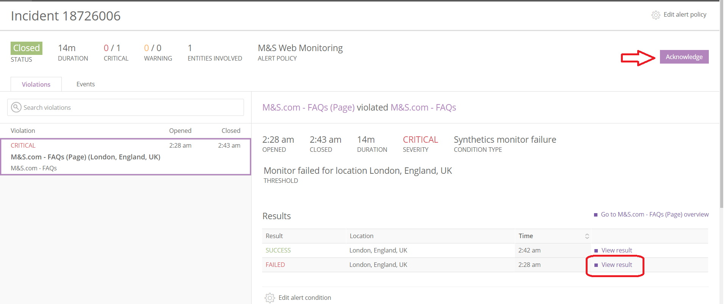

1. The incident details would contain the details of the monitor and would like below. Then click ‘Script Log’ which would give step by step detail of the activity of the monitor.

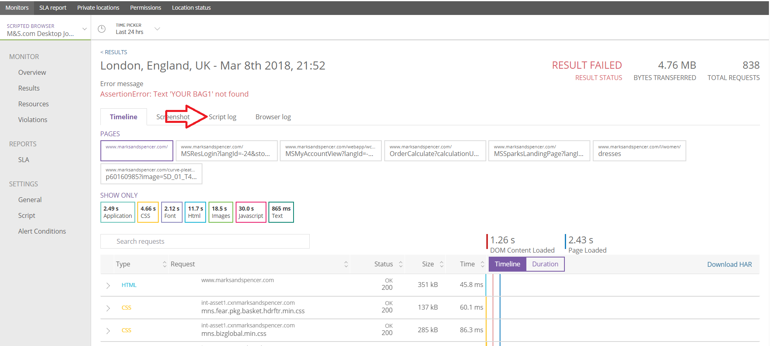

1. Go to the failure step (which is the last step failed) and take the URL relevant from the ‘script log’ detail.

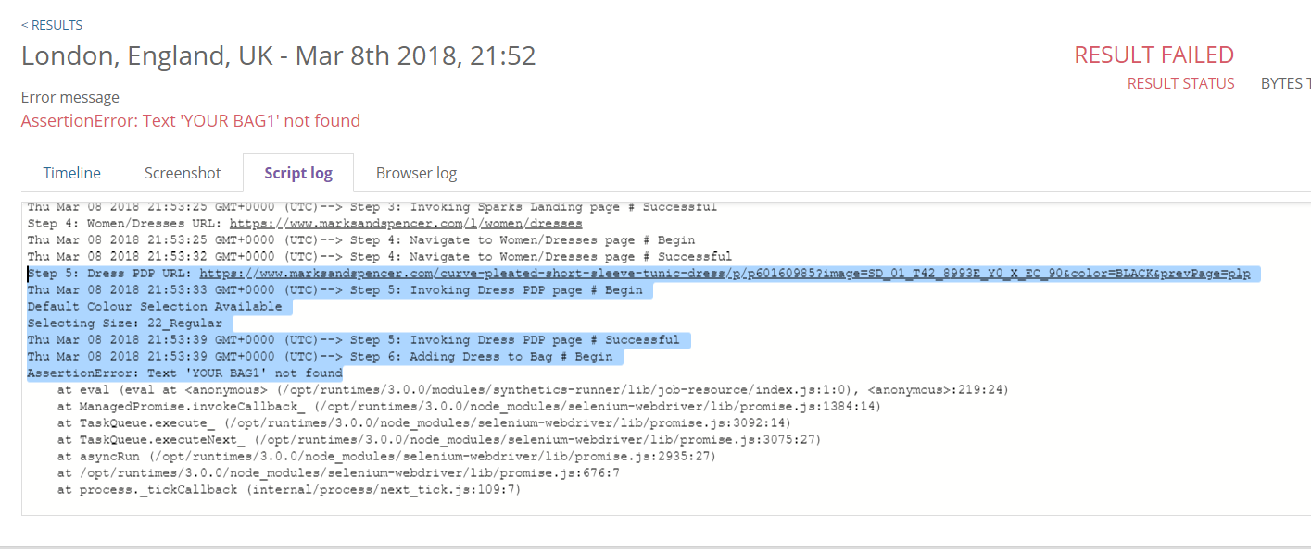

1. Open the browser, paste the url and navigate to the page. Perform the action detailed in the script log. For example, if ‘Adding Dress to Bag’ failed, please add product to the bag.
2. If the action is successful,
   1. Resolve the incident in Remedy.
   2. If the incident occurs again in a short duration, engage ‘on-call Service Manager’ and agree on further actions
3. If the action fails,
   1. Engage ‘on-call service Manager’ and agree on future actions.

Table 2: Journey/PageHits and Support Groups

|  |  |  |
| --- | --- | --- |
| **Journey/PageHit** | **Support Group** | **Support Group Contact** |
| M&S.Com - Corporate Site (Page) | Group Tree | [support@grouptree.com](mailto:support@grouptree.com) |
| M&S.com - Lunchtogo (Page) | EWA | [lty.support@ewa.ltd.uk](mailto:lty.support@ewa.ltd.uk) |
| M&S.com Microsite - Bra fitting (Page) | Booking Bug | [es@bookingbug.com](mailto:es@bookingbug.com) |
| International | Global-e/Demandware | eComm International Support |
| All other journeys/pagehits | Platform Support | eComm Platform Support |

Appendix:

More documentation on New Relic Synthetics is available at the below link:

<https://docs.newrelic.com/docs/synthetics>